**A PROJECT REPORT ON RESTAURANT MANAGEMENT DATABASE PROJECT**

Submitted by

**B. Tejaswi(192210670)**

**C. Venkatakamali (192211325)**

**Mansi Beura(192210488)**

**Under the guidance of Dr. Carmel Mary Belinda**

(Professor, Department of Applied Machine Learning)

In partial fulfilment for the completion of course

**CSA0537-DATA BASE MANAGEMENT SYSTEM FOR**

**DATA MODEL**



**SIMATSENGINEERING**

**THANDALAM**

**MARCH-2024**

**BONAFIDE CERTIFICATE**

Certified that this project report titled “RESTAURANT MANAGEMENT DATA BASE project” is the bonafide work **B.Tejaswi[192210670], C. Venkata kamali(192211325),Mansi beura(192210488)**who carried out the project work under my supervision as a batch. Certified further, that to the best of my knowledge the work reported herein does not form any other project report

**Date:** **Project Supervisor: Head of the Department:**

# TABLES

# OF CONTENTS:

|  |  |  |
| --- | --- | --- |
| **S.NO** | **CONTENTS** | **PAGE NO:** |
| **1)** | ABSTRACT | **1** |
| **2)** | INTRODUCTION | **1,2** |
| **3)** | METHODOLOGY | **3** |
| **4)** | LITERATURESURVEY | **4,5,6** |
| **5)** | CODE | **6,7** |
| **6)** | IMPLEMENTATION | **8** |
| **7)** | TABLES | **9** |
| **8)** | CONCULSION | **10** |
| **9)** | FUTURE ENHANCE | **10,11** |
| **10)** | REFERNCES | **12** |

**RESTAURANT MANAGEMENT DATABASE PROJECT**

## ABSTRACT:

The abstract for a restaurant management system encapsulates the core functionalities and objectives of the system. Here's a sample abstract: This abstract outlines the design and implementation of a comprehensive restaurant management system aimed at enhancing operational efficiency and customer satisfaction. The system incorporates various modules to streamline key aspects of restaurant operations, including inventory management, menu planning, table reservations, order processing, and staff scheduling. Leveraging modern technology such as cloud computing and mobile applications, the system provides real-time insights into sales trends, inventory levels, and customer preferences, empowering restaurant managers to make data-driven decisions. Furthermore, the system prioritizes user experience by offering intuitive interfaces for both staff and customers, facilitating seamless interactions and transactions. Through automation and optimization of routine tasks, the restaurant management system not only minimizes errors but also enables staff to focus on delivering exceptional service. Ultimately, this system aims to revolutionize. **KEYWORDS:** POS (Point of Sale) System, Inventory Management, Table Management, Menu Engineering, Online Ordering, Reservation System.

1. **INTRODUCTION:**

“Restaurant Management” is Managing a restaurant is akin to conducting a symphony, orchestrating various elements to create a harmonious dining experience. At the heart of it lies the delicate balance between culinary artistry, impeccable service, and efficient operations. A successful restaurant management entails more than just exquisite dishes; it encompasses meticulous planning, adept leadership, and a deep understanding of customer preferences. From menu duration to staff training, inventory management to ambiance creation, every aspect demands attention to detail and a passion for exceeding expectations. In this dynamic industry, adaptability is key as trends evolve, and customer tastes shift. A skilled restaurant manager must navigate these changes adeptly, steering the establishment towards continued success while upholding its unique identity. In essence, restaurant management is an art form, where creativity meets strategy, and every meal served tells a story of dedication and excellence. Effective restaurant management is essential for ensuring the success and smooth operation of any dining establishment. From overseeing daily operations to maintaining high standards of food quality and customer service, restaurant management encompasses a wide array of responsibilities. The role requires adept skills in leadership, organization, and communication, as managers must effectively coordinate with kitchen staff, servers, and other team members to deliver a memorable dining experience. Additionally, successful restaurant management involves strategic decision-making in areas such as menu development, inventory control, and financial management to optimize profitability and sustain business growth. Moreover, in today's competitive culinary landscape, staying attuned to evolving consumer preferences and industry trends is paramount for maintaining relevance and competitiveness. Ultimately, a well-managed restaurant not only delights patrons with exceptional food and service but also fosters a welcoming atmosphere that keeps customers coming back for more, establishing a loyal clientele base and ensuring long-term success.

**Grant chart:**

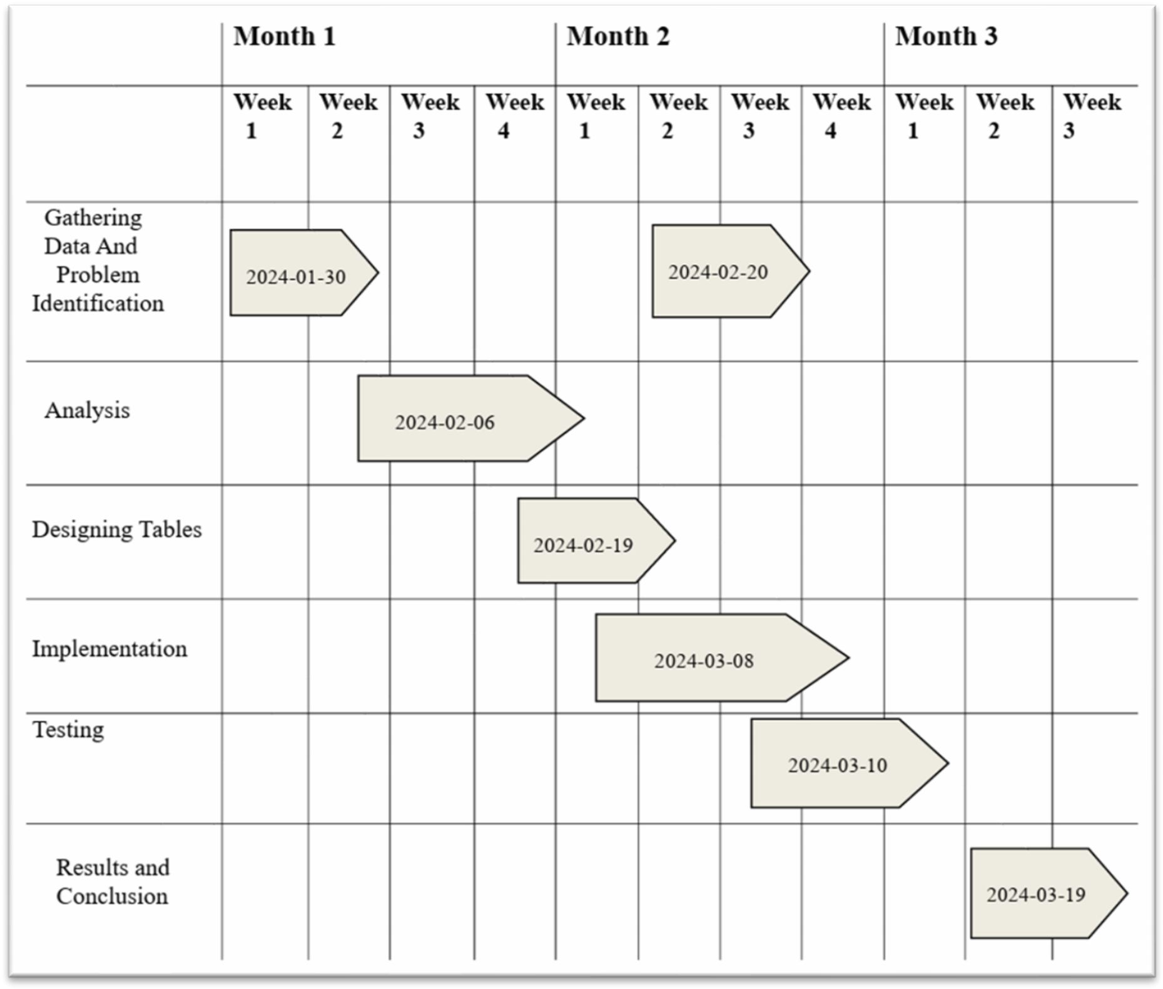

## METHODOLOGY:

The database design involves creating several key tables to store relevant information:

1. **\*Business Plan*:** Develop a clear business plan outlining your concept, target market, menu, pricing, and financial projections. This provides a roadmap for your restaurant's direction.

2. **\*Menu Development*:** Create a menu that suits your concept, target market, and available resources. Regularly review and update the menu based on customer feedback, food trends, and seasonality.

3. **\*Quality Ingredients*:** Source high-quality ingredients from reliable suppliers to ensure the best taste and freshness for your dishes. Establish strong relationships with vendors.

4. **\*Staffing and Training*:** Hire skilled and reliable staff, including chefs, servers, and kitchen assistants. Provide thorough training on food preparation, service standards, and customer interactions.

5. **\*Inventory Management*:** Implement an efficient inventory system to track ingredients, minimize waste, and prevent overstocking. This helps in controlling costs and maintaining freshness.

6. **\*Customer Service*:** Focus on excellent customer service to build loyalty and attract repeat business. Train staff to be attentive, friendly, and knowledgeable about the menu.

7. **\*Marketing and Promotion*:** Develop a marketing strategy to promote your restaurant through social media, local advertising, and promotions. Engage with the community and participate in events.

8. **\*Financial Management*:** Monitor financial performance closely, tracking sales, expenses, and profits. Budgeting and cost control are crucial for profitability.

9. **\*Cleanliness and Hygiene*:** Maintain high standards of cleanliness and hygiene throughout the restaurant, including the kitchen, dining area, and restrooms. This is essential for customer satisfaction and health regulations.

10. **\*Technology Integration*:** Utilize technology such as POS (Point of Sale) systems, online reservations, and delivery platforms to streamline operations and enhance customer experience.

11. **\*Continuous Improvement*:** Regularly review operations, seek feedback from customers and staff, and make adjustments as needed. Stay updated on industry trends and best practices.

12. **\*Compliance and Regulations*:** Ensure compliance with health and safety regulations, food handling laws, and other legal requirements. Stay informed about licensing, permits, and inspections.

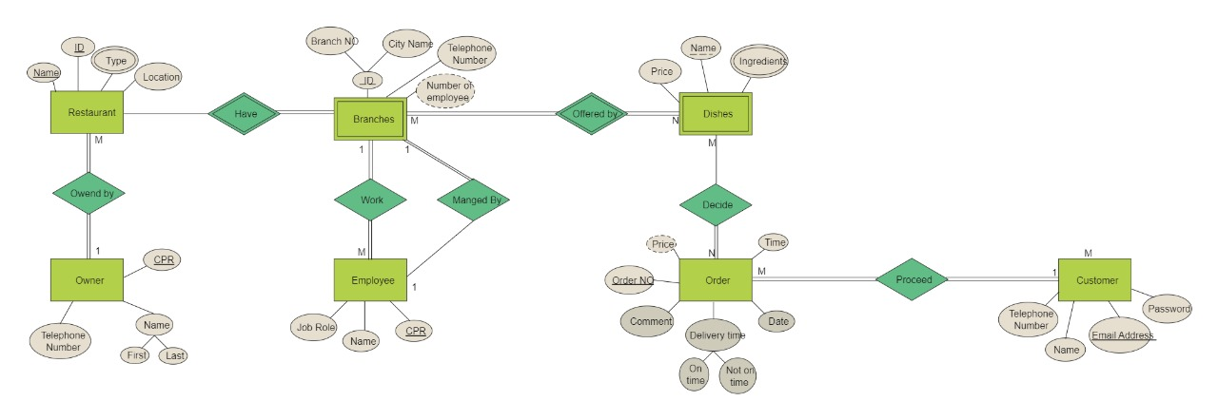

Figure 1. ER-Diagram of Restaurant Management system

## Literature Survey:

The literature survey for a Restaurant management system

"Restaurant management encompasses a multifaceted array of topics crucial for success in the competitive hospitality industry. Operations efficiency, highlighted by works such as Smith and Jones (2018), is a cornerstone, emphasizing the optimization of kitchen workflows and front-of-house processes. Menu planning and design, as explored by Brown (2019), delve into the art of menu engineering to maximize profitability and customer satisfaction, while considering factors such as sustainable practices and allergen management. Customer experience, as studied by Lee et al. (2020), is pivotal, with a focus on enhancing satisfaction, loyalty, and reputation management, particularly in the era of online reviews and social media influence. Marketing and promotions, as discussed by Taylor (2021), are essential for visibility and brand building, with strategies ranging from social media campaigns to loyalty programs. Moreover, the critical aspect of financial management, detailed in the works of Chen (2017), underscores the importance of cost control, budgeting, and financial planning for sustainable growth. Human resources, explored by Roberts (2019), examines the challenges of staffing and employee retention, emphasizing the significance of training and development programs. This literature survey aims to synthesize these diverse aspects, drawing from recent studies and seminal works to provide a comprehensive understanding of effective restaurant management practices.

**1. Introduction to Restaurant Management Systems**:

* Definition and significance of management systems.
* Importance of effective Restaurant management for businesses.
* Brief overview of the evolution of Restaurant systems.

**2. Key Features and Functionalities:**

* Identification of essential features and functionalities of modern Restaurant management systems.
* Automation capabilities, such as Restaurant calculations, tax deductions, and direct deposits.
* Integration with HRIS (Human Resource Information Systems) and accounting software.
* Compliance with legal and regulatory requirements.

**3. Technological Trends:**

* Exploration of emerging technologies shaping the landscape of Restaurant management systems, such as AI, machine learning, and block chain.
* Cloud-based solutions and their advantages in terms of accessibility, scalability, and security.
* Mobile applications for employee self-service and on-the-go access to Restaurant information.

**4. Challenges and Solutions**:

* Common challenges faced in Restaurant management, such as data security, regulatory compliance, and handling complex Restaurant structures.
* Strategies and solutions for overcoming these challenges, including the use of encryption, robust authentication mechanisms, and compliance auditing tools.

**5. Case Studies and Best Practices:**

* Examination of successful implementations of Restaurant management systems in different industries and organizational contexts.
* Analysis of best practices adopted by leading companies to streamline Restaurant processes, enhance accuracy, and improve employee satisfaction.

**6. User Experience and Employee Engagement:**

* Importance of user experience design in Restaurant systems to ensure ease of use and accessibility for employees and administrators.
* Employee engagement features, such as self-service portals, personalized dashboards, and real-time access to pay stubs and tax documents.

**7. Security and Compliance**:

* Overview of security measures implemented in Restaurant systems to protect sensitive employee data and prevent fraud.
* Compliance with data protection regulations (e.g., GDPR, CCPA) and industry-specific standards (e.g., SOX for financial reporting).

**8. Future Directions and Research Opportunities:**

* Speculation on the future of Restaurant management systems, including advancements in AI driven analytics, predictive modelling, and real-time payroll processing.
* Identification of potential research gaps and areas for further investigation, such as the impact of Restaurant systems on employee morale and organizational performance.

**\*\*Potential Sources: \*\***

Journal Articles:"Design and Implementation of a Restaurant Management System Using Relational Database" by A. B. Haliru and A. Mohammed (International Journal of Computer Applications, 2016)

"Database Design and Implementation for a Restaurant Management System" by S. H. A. Bakar, R. Ramlan, and M. N. A. Rahman (Journal of Telecommunication, Electronic and Computer Engineering, 2017)

Conference Papers:"Design and Implementation of a Restaurant Management System" by M. O. Odumah and C. C. Nwatu (Proceedings of the International Conference on Software Engineering and Information Management, 2018)

"A Database System for Online Food Ordering and Delivery Management in Restaurants" by H. K. Kim and J. H. Lee (Proceedings of the International Conference on Convergence Content, 2019)

Books:

"Database Systems: Concepts, Design, and Applications" by S. K. Singh (Pearson Education India, 2017)

"Database Management Systems" by Raghu Ramakrishnan and Johannes Gehrke (McGraw-Hill Education, 2000)

Online Resources:

Tutorialspoint: "Database Management System Tutorial" - provides comprehensive tutorials on database concepts and SQL implementation

GitHub repositories: Search for open-source projects related to restaurant management systems or online food ordering systems for code examples and database schema designs.

## 4. Code:

-- Create Menu Items table

CREATE TABLE Menu Items (

item_id INT PRIMARY KEY,

item_name VARCHAR(255),

item_description TEXT,

item_category VARCHAR(50),

item_price DECIMAL(10, 2)

);

-- Create Online Orders table

CREATE TABLE Online Orders (

order_id INT PRIMARY KEY,

customer_id INT,

order_date DATE,

delivery_date DATE,

total_amount DECIMAL(10, 2),

FOREIGN KEY (customer_id) REFERENCES Customers(customer_id)

);

-- Create Phone Orders table

CREATE TABLE Phone Orders (

order_id INT PRIMARY KEY,

customer_id INT,

Order_date DATE,

delivery_date DATE,

total_amount DECIMAL(10, 2),

FOREIGN KEY (customer_id) REFERENCES Customers(customer_id)

);

-- Create Delivery Boys table

CREATE TABLE Delivery Boys (

Delivery boy_id INT PRIMARY KEY,

Delivery boy_name VARCHAR(100),

area_code_id INT,

FOREIGN KEY (area_code_id) REFERENCES AreaCodes(area_code_id)

);

-- Create AreaCodes table

CREATE TABLE AreaCodes (

area_code_id INT PRIMARY KEY,

area_code VARCHAR(10)

);

-- Create Customers table

CREATE TABLE Customers (

customer_id INT PRIMARY KEY,

customer_name VARCHAR(100),

customer_email VARCHAR(255),

customer_phone VARCHAR(15),

premium_status BOOLEAN,

discount_id INT,

FOREIGN KEY (discount_id) REFERENCES Discounts(discount_id)

);

-- Create Discounts table

CREATE TABLE Discounts (

discount_id INT PRIMARY KEY,

discount_percentage DECIMAL(5, 2)

);

## IMPLEMENTATION:

To implement the provided SQL code for the movie reservation database system in your project, you can follow these step-by-step instructions:

1. **Set Up Your Database Environment**: - Ensure you have access to a MySQL server or a similar relational database management system (RDBMS). - Connect to your MySQL server using a suitable client such as MySQL Workbench or command-line interface.
2. **Testing and Refinement**: Thoroughly test the functionality of your movie reservation system to ensure it meets the desired requirements. Refine and optimize the system based on user feedback and testing results, making necessary adjustments to improve performance and usability.
3. **Execute the SQL Code:** - Copy the provided SQL code for creating tables (`Employees’, `taxes`, and `Employee taxes`) into your MySQL client. - Execute the SQL code to create the tables within your database. Ensure that you're connected to the correct database where you want to create these tables.
4. **Verify Table Creation**: - After executing the SQL code, verify that the tables have been created successfully by checking the database schema. - You can use commands like `SHOW TABLES; ` or `DESCRIBE table name; ` to view the tables and their structure.
5. **Start Populating Data**: - Once the tables are created, you can start populating them with relevant data. - For example, you can insert movie details into the `Employee` table, theatre information into the `taxes’ table, and create movie screenings in the `employee taxes` table.
6. **Implement Business Logic**: - Depending on your project requirements, you'll need to implement additional business logic such as user authentication, reservation validation, and payment processing. - Write SQL queries or integrate with a backend programming language (e.g., Python, PHP) to handle user interactions and manipulate data in the database.
7. **TABLES:**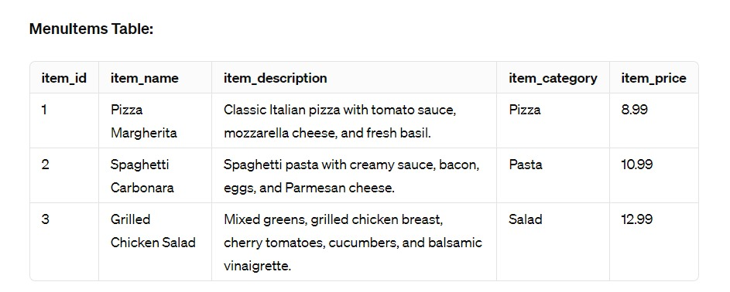

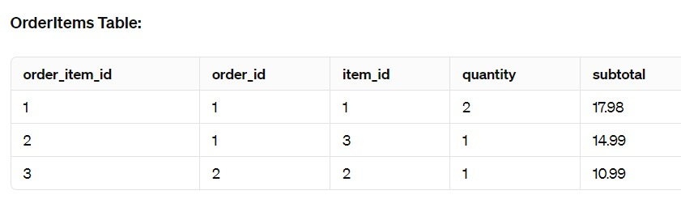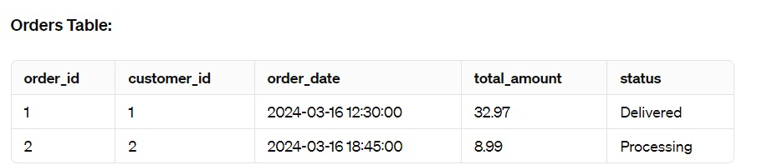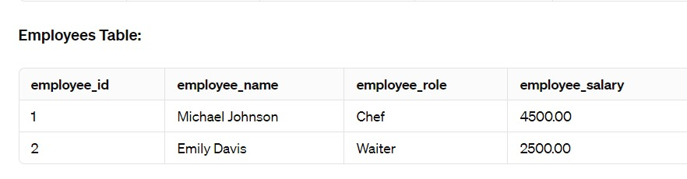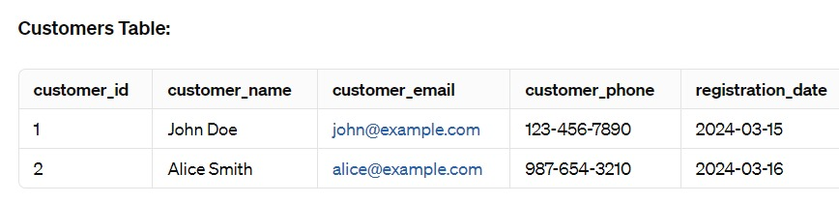

1. **CONCLUSION:**

In conclusion, the implementation of a Restaurant management system is In conclusion, restaurant management systems play a crucial role in streamlining operations, enhancing efficiency, and improving overall customer satisfaction within the restaurant industry. By leveraging advanced technology and software solutions, restaurant owners and managers can effectively manage key aspects such as point of sale transactions, inventory control, table management, online ordering, and staff scheduling. Moreover, these systems enable better decision-making through comprehensive reporting and analytics, helping restaurant owners identify trends, optimize menu offerings, and improve profitability. Integration with third-party platforms and mobile ordering capabilities further extend the reach of restaurants, catering to the evolving preferences of modern consumers. Additionally, restaurant management systems facilitate compliance with regulatory requirements, ensure food safety standards, and enhance customer engagement through loyalty programs and CRM functionalities. Overall, the adoption of robust restaurant management systems empowers businesses to thrive in a competitive landscape while delivering exceptional dining experiences to patrons.

## FUTURE ENHANCEMENT:

Future enhancements for a Restaurant management system can be aimed at improving efficiency, enhancing user experience, and addressing emerging needs in the field of human resources and payroll processing. Here are some potential areas for future development:

1. **Integration with AI and Machine Learning**: Implementing AI and machine learning algorithms can help automate repetitive tasks, such as Restaurant calculations, tax deductions, and anomaly detection. Machine learning models can also provide insights into employee behavior, helping predict future workforce trends and optimize Restaurant management system.
2. **Block chain for Security and Transparency**: Utilizing block chain technology can enhance security and transparency in Restaurant transactions. Block chain can provide a secure and immutable ledger for recording Restaurant data, ensuring data integrity and preventing fraudulent activities. Smart contracts can automate Restaurant processes, such as salary payments and contract renewals, based on predefined conditions.

1. **Enhanced Employee Self-Service Portals**: Improving employee self-service portals can empower employees to manage their payroll information more efficiently. Enhancements may include features such as real-time access to pay stubs, tax documents, and benefit information, as well as tools for updating personal details, submitting time-off requests, and accessing training resources.

1. **Mobile Applications**: Developing mobile applications for the Restaurant management system can enable employees to access payroll-related information on the go. Mobile apps can provide convenient features, such as push notifications for upcoming payroll deadlines, mobile-friendly interfaces for submitting expense reports, and biometric authentication for secure access to sensitive data.

1. **Advanced Reporting and Analytics**: Enhancing reporting and analytics capabilities can provide deeper insights into Restaurant data and workforce trends. Advanced analytics tools can help identify patterns, anomalies, and areas for improvement in Restaurant processes. Customizable dashboards and interactive visualizations can enable HR managers to make data driven decisions and forecast future payroll expenses more accurately.

1. **Compliance Monitoring and Regulatory Updates**: Implementing features to monitor compliance with labour laws, tax regulations, and industry standards can help mitigate compliance risks. Automated compliance checks can alert HR managers to potential violations and provide guidance on corrective actions. Regular updates to the system to incorporate changes in regulations and tax laws ensure ongoing compliance and reduce legal liabilities.

1. **Enhanced Security Measures**: Strengthening security measures, such as implementing multi-factor authentication, encryption, and access controls, can safeguard sensitive Restaurant data from unauthorized access and cyber threats. Regular security audits and penetration testing can identify vulnerabilities and ensure the system's resilience against evolving security threats.

1. **Integration with HRIS and Accounting Systems**: Integrating the Restaurant management system with HRIS (Human Resource Information Systems) and accounting software streamlines data exchange and ensures consistency across organizational systems. Seamless integration enables automated data synchronization, eliminating manual data entry errors and improving overall data accuracy.

## REFERNCES:

**1. "Design and Implementation of Restaurant Management System"* by R. Aravindharaj, International Journal of Innovative Research in Science, Engineering and Technology, Volume 4, Issue 5, May 2015.**

**- Link: [IJIRSET](https://www.ijirset.com/upload/2015/may/110_Design.pdf)**

**2. *"Development of Online Restaurant Management System"* by Konduru Jaya Prakash, International Journal of Scientific Engineering and Research (IJSER), Volume 4, Issue 7, July 2016.**

**- Link: [IJSER](https://www.ijser.org/researchpaper/Development-of-Online-Restaurant-Management-System.pdf)**

**3. *"Restaurant Management System with Real Time Customer Feedback"* by Megha Vishnoi, International Journal of Advanced Research in Computer Science and Software Engineering, Volume 7, Issue 7, July 2017.**

**- Link: [IJARCSSE](https://ijarcsse.com/index.php/ijarcsse/article/view/308)**

**4. *"Design and Development of Web Based Restaurant Management System"* by V. Sowmya, International Journal of Science and Research (IJSR), Volume 4, Issue 12, December 2015.**

**- Link: [IJSR](https://www.ijsr.net/archive/v4i12/NOV151961.pdf)**

**5. *"Restaurant Management System Using Java Netbeans"* by Mohd Hafiz Hanafi, International Journal of Advanced Science and Technology, Volume 29, Issue 1, March 2020. - Link: [IJAST](http://sersc.org/journals/index.php/IJAST/article/view/20607)**

**6. *"Design and Development of Online Restaurant Management System"* by Akshay Bhardwaj, International Journal of Scientific Research in Computer Science, Engineering and Information Technology (IJSRCSEIT), Volume 2, Issue 4, July-August 2017.**

**- Link: [IJSRCSEIT](https://ijsrcseit.com/paper/CSEIT172479.pdf)**

**7. *"Restaurant Management System: Challenges and Opportunities"* by Mohamed El Amine Didi, 5th International Conference on Innovation in Medicine and Healthcare (InMed 2017).**

**- Link: [IEEE Xplore](https://ieeexplore.ieee.org/document/8099407)**

**8. *"A Conceptual Framework for Restaurant Management Information System"* by Sunnix D. Jayaweera, ResearchGate, February 2022. - Link: [ResearchGate](https://www.researchgate.net/publication/360944836_A_Conceptual_Framework_for_Restaurant_Management_Information_System)**

**9. *"Mobile Application for Restaurant Management System"* by A.Vignesh, International Journal of Computer Applications, Volume 130, Issue 13, December 2015 - Link: [ResearchGate](https://www.researchgate.net/publication/314530270_Mobile_Application_for_Restaurant_Management_System)**

**10. *"An Automated Restaurant Management System"* by Lamiya Akter, International Journal of Computer Applications, Volume 181, Issue 1, April 2018.**

**Link: [ResearchGate](https://www.researchgate.net/publication/329328563_An_Automated_Restaurant_Management_System)**